SENATE, No. 1589
STATE OF NEW JERSEY
219th LEGISLATURE
INTRODUCED FEBRUARY 13, 2020

Sponsored by:
Senator JAMES BEACH
District 6 (Burlington and Camden)

SYNOPSIS
Prohibits private correctional facilities from detaining persons pursuant to agreement with federal immigration authorities.

CURRENT VERSION OF TEXT
As introduced.
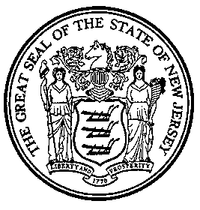

An Act concerning private correctional facilities and supplementing Title 30 of the Revised Statutes.

Be It Enacted by the Senate and General Assembly of the State of New Jersey:

- a. As used in this act:
“Federal immigration authority” means an agency of the United States government responsible for implementing and enforcing federal immigration law, including but not limited to, the United States Immigration and Customs Enforcement, United States Customs and Border Protection, and United States Citizenship and Immigration Services within the Department of Homeland Security.
“Intergovernmental service agreement” means an agreement between a private correctional facility and federal immigration authority to detain persons under the authority of the Immigration and Nationality Act (8 U.S.C. s.1101 et seq.).
"Private correctional facility" means any private facility that detains persons pursuant to an intergovernmental service agreement, memorandum of understanding, or other contract or agreement with a federal immigration authority.
b. A private correctional facility operating in this State shall not detain persons under the authority of the Immigration and Nationality Act (8 U.S.C. s.1101 et seq.) pursuant to an intergovernmental service agreement, memorandum of understanding, or any other contract or agreement with a federal immigration authority.

2. This act shall take effect immediately.

STATEMENT

This bill prohibits private correctional facilities from detaining people based on immigration status pursuant to an intergovernmental service agreement, memorandum of understanding, or any other contract or agreement with a federal immigration authority. The bill defines “federal immigration authority” as an agency of the United States government responsible for implementing and enforcing federal immigration law, including but not limited to, the United States Immigration and Customs Enforcement, United States Customs and Border Protection, and United States Citizenship and Immigration Services wit0hin the Department of Homeland Security.

